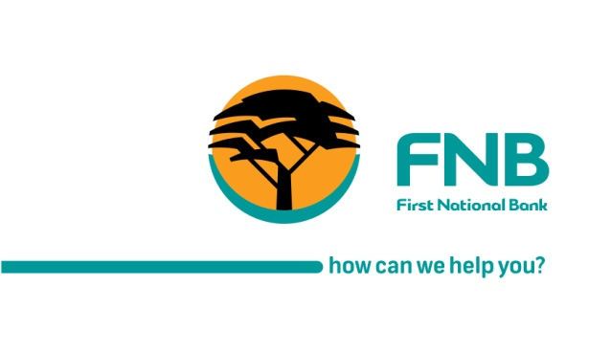

29 August 2017

For Immediate Release

PRESS RELEASE

WUC-FNBB partner to offer water bill payment gateway

Gaborone - Water Utilities Corporation (WUC) and First National Bank Botswana are pleased to announce yet another exciting project following the successful completion of Somarela Thothi project. This collaboration saw WUC developing self-service platforms accessible via cellphone dial code *186# and website to facilitate convenient access to WUC services by their customers. The service is available to all WUC customers, whether or not they bank with FNB.
The service offers WUC customers the opportunity to pay for their water bill from the convenience of any location. To use the service, customers are required to disclose the following: card number, Card Verification Value (CVV) number and card expiry date as well as customer and contract numbers with WUC. Users can also report issues such as leakages and enquire on outstanding bill statements. On the mobile phone, the service is available through the code: *186# and the service is accessible from all mobile devices across all cellular networks. The service is also available on the WUC website at www.wuc.bw.

Commenting on the partnership, FNB Chief Executive Officer, Steven Bogatsu said; the partnership between FNB & WUC provides WUC with a cost effective revenue collection by bridging the gap between the payee and the payer. From a management accounting perspective, it will also be easy for WUC to reconcile bill payments; a development we are proud to be a part of.”

Chief Executive Officer of WUC, Mmetla Masire added, “This exciting collaboration solidifies our transformation journey from over the counter transactions to seamless self-service at customer’s convenience. For me, this empowers water users with the much needed unlimited access to WUC services.”

All transactions via the website and dial code are secure

-End-
For more information or interview opportunities, please contact:
Kemiso Ben
Communications Manager
First National Bank of Botswana Limited
Tel: +267 370 6084
Fax: + 267 390 6679
Email: kben@fnbbotswana.co.bw

Khumo Mugibelo
Acting Corporate Communications Manager
Water Utilities Corporation
Tel: +267 360 4500
Fax: + 267 397 3852
Email: kmugibelo@wuc.bw

